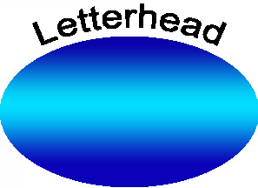
Lead

Agency

September 25, 2023

California Department of Water Resources Division of Regional Assistance
Financial Assistance Branch
715 P Street, Sacramento, CA 95814

Re: No objection or legal action – Grant Agreement Project # and Title - Grant Agreement No. 46oooxxxxx

Dear DWR staff,
This letter certifies that there [were/were not] legal challenges filed against the Notice of Exemption (NOE) for the above Project.
[If the NOE was filed [use the paragraphs below:]
The [Lead Agency] filed the NOE on [date] with the County Clerk of [County] [and/or] the State Clearinghouse. The public review period for the NOE began on [date] and ended on [date]. The filing of the NOE began a xx-day statute of limitations on legal challenges to the public agency’s approval of the project under CEQA.
The [Lead Agency] confirms that there are no exceptions applicable to the project under §15300.2 of the CEQA Guidelines.
Additionally, the [Lead Agency] confirms that the NOE project includes the DWR grant funded project above.
[If the NOE was not filed [use the paragraphs below:]
The [Agency] did not file the NOE. The 180-day statute of limitations period has passed since the time the [Agency] approved the Project under CEQA. [explain the status of legal actions: example: there were no legal actions against the project OR explain the legal action(s) if any]
The [Lead Agency] confirms that there are no exceptions applicable to the project under §15300.2 of the CEQA Guidelines.
Additionally, the [Lead Agency] confirms that the NOE project includes the DWR grant funded project above.

Please contact me if you have any questions at [Contact Info.]
Sincerely,
Name
Title

