North Richmond Community Visioning: Outreach and Survey Findings

Suggested Citation: Gonzalez, J., Brown, J., and Woodfill, L., Gibbons, S., Strickland, J., Guardian, S., North Richmond Community Visioning: Outreach and Survey Findings. The Watershed Project. San Francisco Estuary Partnership. Oct. 2017.

The Watershed Project (TWP) and The San Francisco Estuary Partnership (SFEP) began coordinating in February 2017 to develop a strategy for gathering input from the North Richmond community to learn how they envision the future of the North Richmond Shoreline, which is defined in this project as the coastal region from Point San Pablo to Point Pinole. TWP began the project by designing a set of surveys to capture information on how residents currently use the shoreline, what they would like to see on the shoreline in the future, and what are they concerns on and near the shoreline.
From April 2017 to September 2017, TWP staff implemented the shoreline survey at 14 events in North Richmond. These included local council meetings, community events, and community volunteer events. Included in these events was a tour of the shoreline, which TWP developed and hosted as a component of this project. In all, TWP surveyed 284 North Richmond residents.

Key Findings
The results of the surveys tell an interesting and important story about how residents use and envision the North Richmond Shoreline. When asked what they currently do on the shoreline, the most popular response (37 percent of all responses), was to walk or hike. Other significantly reported uses were gathering and biking, each at 13 percent of responses.
The top three things that residents said that they would like to see more of on the shoreline were 1. sandy beaches, 2. hiking trails, and 3. restaurants. While the top two categories are natural amenities, the third choice is significant because it shows that locals may want more commercial destinations on the shoreline.
The surveys also reveal that the largest barrier for residents visiting the shoreline is a lack of knowledge regarding shoreline activities. Nearly every respondent (94 percent) responded that they would visit the shoreline more if they knew of more things to do there. Another large proportion (90 percent) said that walking access is a barrier to visiting the shoreline. A majority of residents also responded that bus access (66 percent) and lack of car parking (66 percent) also prevented more shoreline visits.
On and near the shoreline, North Richmond residents are most concerned about air and water pollution. The large majority (85 percent) are also concerned about a lack of local jobs, flooding damage to buildings (73 percent), and raising rents and home prices (73 percent).
The next four sections below provide more details about the project’s process and further analysis of the survey findings.

I. Survey Methodology
At the onset of the project, TWP identified the main objective of the survey as to gather input about North Richmond Community’s opinions about issues and future development on the North Richmond Shoreline. To begin the process of developing a system for collecting information from residents, TWP staff first considered the relevant challenges. TWP identified the biggest obstacles to be language barriers and competing for participants attention at events. TWP also considered observations from organizational partners that previously conducted community input activities in the North Richmond community. From the firm, Restoration Design Group, TWP learned that residents often like to stand in a semicircle around a point of focus and freely discuss opinions.

To address the challenges and community culture, TWP created three survey parts two of which were on large colorful posters that publicly displayed survey participants’ input. These visually based surveys components included “The North Richmond Shoreline Needs More…” which captured information on desired future shoreline features, and “What do you do on the North Richmond Shoreline?” which collected data on current residential uses of the shoreline.

The visual and public nature of these surveys proved to successfully capture event participants’ attention in at least two ways. First the large colorful displays invited people to engage. Second, the setup afforded residents the opportunity to gather and discuss the surveys, and this sight of gathered participants often drew more participants to the surveys. These surveys also helped some monolingual Spanish speakers participate as the process for participating was readily understood through visual cues.

The visual style of engagement appeared to be more effective for encouraging participation than the individual written a multiple-choice survey style, which TWP also distributed during this project. The third survey part captured information on concerns about issues near the North Richmond Shoreline and barriers to use of the shoreline. This part of the suite of surveys was a bit less popular in terms of participation, but was designed to be more private due to the sensitive nature of the requested information.

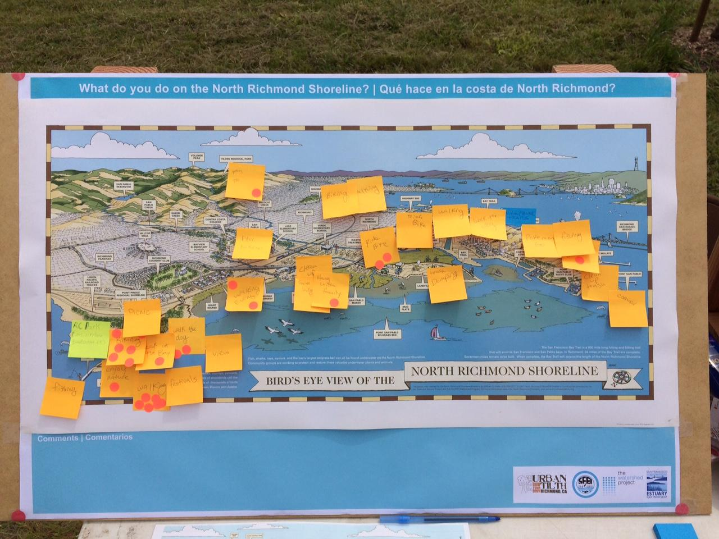
Example of the “What Do You Do Survey” from the Green Festival, 4.22.17.

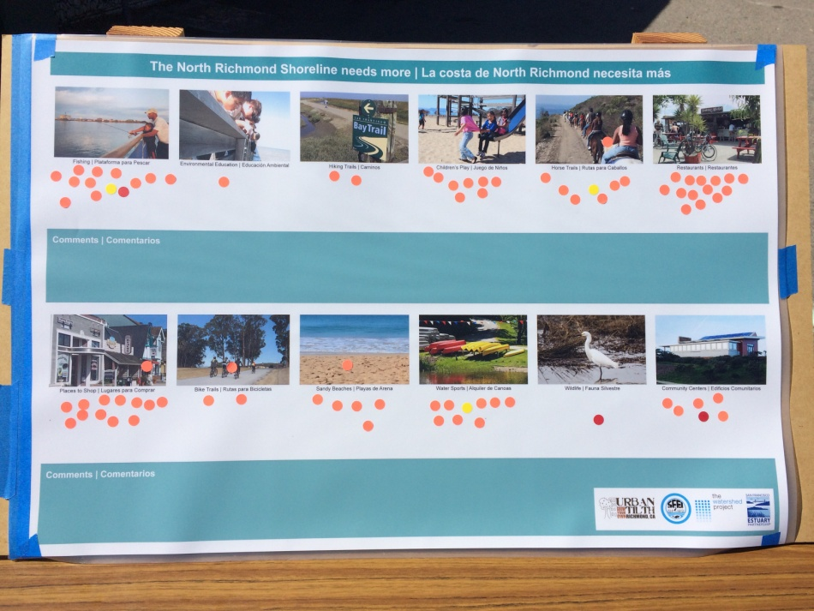

Example of the “What Do You Want” survey from Hood Day, 8.12.17.

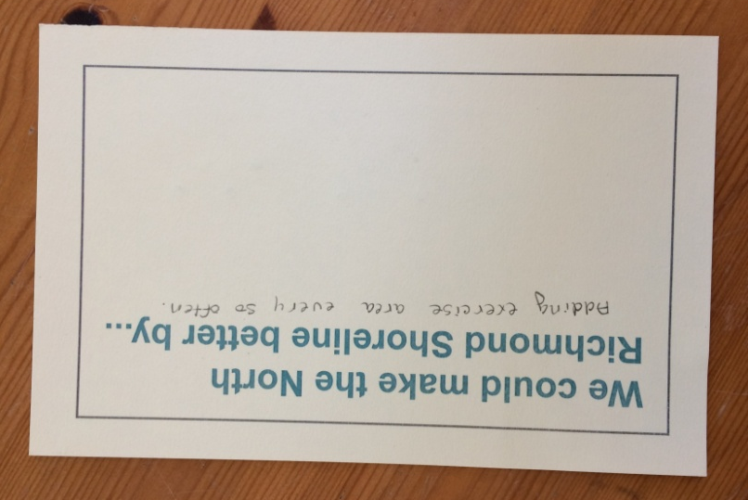
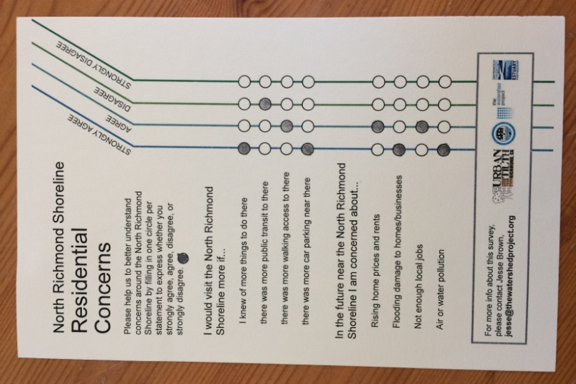

Example of the “Concerns” survey from the Green Festival, 4.22.17.

II. Events
TWP implemented the shoreline community visioning survey at 14 events in North Richmond with support from SFEP during the course of the project. The events and their dates are listed below.

Event | Date
North Richmond Green Festival | 4.22.17
Dotson Marsh Opening | 4.22.17
North Richmond Municipal Advisory Council | 5.02.17
TWP Shoreline Tour | 5.20.17
North Richmond Municipal Advisory Council | 8.01.17
Urban Tilth Summer Interns Program | 8.08.17
Hood Day | 8.12.17
Urban Tilth Creek Clean Up | 8.19.17
Atchison Village Neighborhood Council | 8.24.17
Block Ambassadors | 9.02.17
Urban Tilth Farm/ John Gioia Community Meeting | 9.09.17
Parchester Village Neighborhood Council | 9.13.17
Verde Elementary Parent Coffee Hour | 9.21.17
Richmond High Environmental Club | 9.21.17

North Richmond Shoreline Tour
TWP organized a tour of the North Richmond Shoreline to provide residents with an opportunity to visit and learn about the uniqueness of the area and threat of sea level rise. On May 20th, 2017, TWP picked up North Richmond residents by bus from Shields-Reid Community Center and went to the newly opened Dotson Family Marsh. At the marsh TWP staff presented on the ecology and form of the area while leading the group on a 1.5 mile hike along the coast to Point Pinole Regional Shoreline. At Point Pinole residents explored the beach area while receiving additional shoreline education. Tour participants then completed the suite of surveys and finished the day with a picnic in the park. 29 community members completed surveys while a total of 36 participated during the event.
The Biggest challenge TWP experienced while implementing the tour was securing participants. 69 residents RSVP’d to the event but only 15 of those people arrived for the event. TWP staff recruited additional tour and survey participants in Point Pinole to supplement numbers.

III. Survey Results
What Residents Do on the Shoreline
One survey implemented in this project asked “What do you do on the North Richmond Shoreline?” Participants were asked to write on a sticky-note any activities that they personally perform on the shoreline and to attach the note in the general area where they performed the activity. The distribution of the results can be viewed in Figure 1 below.

Other” includes the following activities: boating volleyball, diving, ride horses, playground, gun range, dump trash, zumba, swim fishing.

As Figure 1 shows, hiking or waking has the largest share of current shoreline uses. This figure could be even larger if we included “Walk Dog,” as part of the hiking/walking category. The walking categories combined make a total of 44 percent of total responses.

What Residents Want on the Shoreline

Another survey used in this project asked participants to respond to the prompt “The North Richmond Shoreline needs more…” This aimed to capture information on things local residents would like to have more of on the shoreline in the future. With input from SFEP TWP created a limited set of categories to include in the survey, which are as follows:

- Fishing Piers
- Environmental Education
- Hiking Trails
- Children’s Play
- Horse Trails
- Restaurants
- Community Centers
- Wildlife Water Sports
- Sandy Beaches
- Bike Trails
- Places to Shop

The survey featured a photo for each category and an empty space underneath where survey participants place small orange stickers “to vote.” Each participant received three stickers and could place these stickers under any three different categories to indicate their preference. Survey results shown in Table 1 reveal that the most desired amenity is sandy beaches, followed by hiking trails, restaurants, children’s play, and wildlife.

Barriers for Residents to Visit the Shoreline
The multiple-choice survey asked participants to indicated whether they strongly agree, agree, disagree, or strongly disagree to a list of statements. The first section provided statements concerning barriers to use of the shoreline. The goal of this section was to learn what may be preventing residents from using the shoreline.

From Table 2 it appears that respondents felt that the biggest barrier to visiting the shoreline is an understanding of its uses. Almost 60 percent of residents strongly agreed and about 35 percent agreed that they would visit the shoreline more if they knew of more things to do there. This could mean that residents do not know the shoreline well, or that they think that shoreline activities are limited. This could also suggest that outreach and education about shoreline uses may be an effective way to increase visitation to the area.

Residents’ Concerns on or Near the Shoreline
A second section of the multiple-choice survey included a brief set of statements related to either environmental justice or livability issues on or near the shoreline. Among the possible shoreline issues listed, respondents were most concerned about air or water pollution at 90 percent. This may be due to the current and historical presence of industry in the area. The Chevron refinery sits visibly along the North Richmond Shoreline and regularly emits white clouds from tall brick stacks. Table 3 also demonstrates that the majority of residents are concerned about rising home prices and rents, flooding damage to buildings, and not having enough local jobs.

IV. Recommendations
North Richmond Shoreline users appreciate the opportunity to walk along the shoreline, and they see the shoreline as a place to gather and spend time with family and friends. Based on the main responses to what they want to see more of on the shoreline (1. sandy beaches, 2. hiking trails, and 3. Restaurants) it is important to create a vision that incorporates a diversity of potential destinations for the community to enjoy, including natural and commercial uses.
The surveys revealed that the largest barrier for residents visiting the shoreline is a lack of knowledge regarding shoreline activities, lack of walking access to those points of interest, and lack of public transit access. As a way to mitigate this problem a comprehensive community trail mapping and trail network could be development to connect the residential neighborhoods to the shorelines parks and amenities. Way findings might be installed to guide community members and regional visitors to the shorelines points of interest and access points. And a strategy for local tours (such as YMCA hosted walks) or increased bus routes could be explored with local transit authorities.
On and near the shoreline, North Richmond residents are most concerned about environmental justice issues such as clean air and clean water and risk of flood damage. Also great numbers express concern about lack of local jobs and risks of gentrifications. The recommendations are to make sure that potential developments along the shoreline include community employment options during construction and after completion.
Green Collar Jobs are encouraged and should be accommodated as part of the community training options. This could include a long list of options such as marsh restoration technician, creek restoration technician, urban farmer, interpreter ranger, gardener, parks ranger, land manager, nursery technician, plant biologist, marine biologist, wetlands biologist, environmental educator, among others.
The compatible development options could include some types of restaurants, sporting fields and some low impact commercial uses that will yield other types of employment opportunities.
For the last 20 years the community has voiced their concern about displacement and environmental justice. A long-term plan for dealing with sea level rise adaptation in communities at risk, like North Richmond, should include a management plan for pollutants from Chevron and other industries placed along the shoreline.
A long term affordable housing plan should also be accommodated near the transition zone to accommodate residents from areas that are likely to be affected by sea level rise in the next 20 years.

